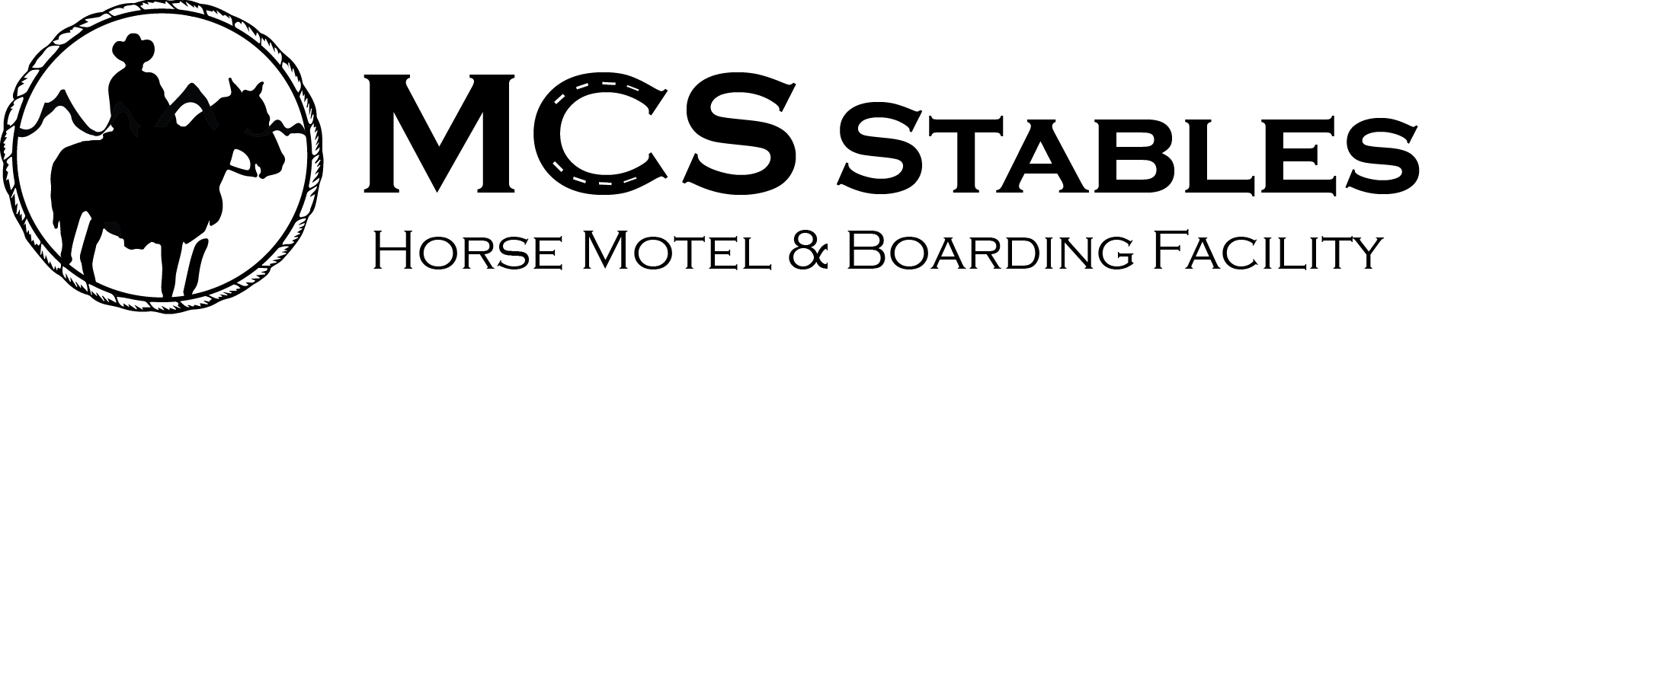
OVERNIGHT BOARDING AGREEMENT

Owner Information: Date: ____/_____/_____

Name: _________________________________ Email: ____________________________________

Home Address: _____________________________________________________________________

City: ___________________________ ST: _________ Zip: ____________________

Cell: (_____)________________________ Other: (______)____________________________

Staying locally at: ______________________________________ Phone: (____)_______________

Horse(s): _________ @ $_________ /day x ______ days Horse(s): $ ______________

Camping: $_________ /day x ______ days Camping: $ ______________

Total: $ ______________

How did you hear about us? ___________________________________________________________

PLEASE SIGN BACK OF THIS FORM

_________________________________________________________________________

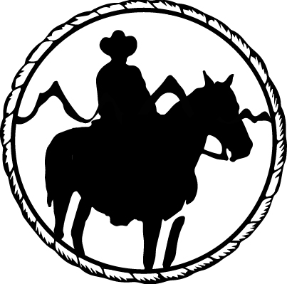

MCS STABLES RECEIPT

Date: ____/_____/_____

Received From: ______________________________ $ _______________________

THE NATIONAL EQUINE ACTIVITY LIABILITY LAW

To All Riders, Drivers, Students and Guests:

The State of Arizona in 1994 passed the Equine Activity Liability Law through a legislative act designed to limit frivolous and unnecessary lawsuits and for the protection of the Horse Businesses in the State of Arizona.

This law recognizes the fact that horses are unpredictable and cannot be controlled all the time.

An equine professional or an Equestrian Center is not liable for injury or death of a participant in equine activities resulting from the inherent risks of equine activities pursuant to RCW 4.24.530

Participants accept responsibility for their own riding level and they are responsible for their own performance on and around the horse.

I acknowledge that I have read and understand the above statement.

_______________________________ ____/_____/______
Signature Date

